***The Business Model Canvas***

***Designed for: FothPay***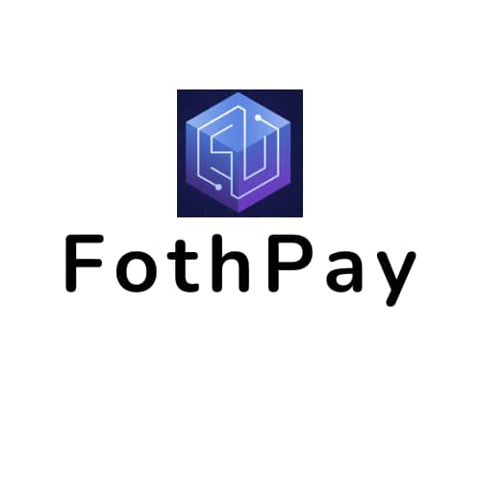

***Designed by: TEAM 1***

|  |  |  |  |  |  |
| --- | --- | --- | --- | --- | --- |
| ***Key Partners***  *AFRICA GAMING GUILD*  *VISA*  *Mastercard.SecureCode*  *MasterCard*  *paygate*  *VerifiedbyVISA* | ***Key Activities***  *Website Development & Maintenance*  *App Development & Maintenance*  *Marketing*  *Traffic Generation*  *Traffic Management* | ***Value Propositions***  Ensure adequate communication of planned system downtime  Making money by playing games  Two factor Authentication(2fa) on Account  Buy & Sell of Giftcard  Refill for Customers  Buy, sell,send ,receive,store or spend bitcoin | | ***Customer Relationships***  ***Community***  ***Help Center***  ***Live CHAT***  ***Sms & Email*** | ***Customer Segments***  Internet users  Platform Users |
|  | ***Key Resources***  platform  technology  game features |  | | ***Channels***  *Internet*  *Website*  *Advertisements* |  |
|  |  |  | |  |  |
|  |  |  | |  |  |
|  |  |  | |  |  |
|  |  |  | |  |  |
|  |  |  | |  |  |
|  |  |  | |  |  |
| ***Cost Structure:***  *database management system*  *staff development*  *marketing*  *maintenance of the FothPay platform* | | | ***Revenue Streams:***  Data subscription  Airtime purchase  Internet subscription  Tv subscription  Transfer charge/Fee | | |
|  | | |  | | |
|  | | |  | | |